Git Advanced commands
- git fetch ---- download the data from globe repository but it will not merge {or it will not show in to our folder}
- git merge ---- it will merge {add} the changes to local repository
{git pull – git fetch +git merge]
- git commit –amend -m “message” ---- this will help to replace new commit with exist commit.
- Git mv <filename> <new file name> ---- it change the file name
- git rm –cached <filename> --- it remove file from local repository not from file system
- git rm -f <filename> -- it will remove file from local repository and also in file system also
- git stash save <some name>----- which save changes temporary
- git stash list --- give list of stash element.
- git stash show ---used to display the changes recorded in a stash entry
- git stash drop --- used to delete most recently created git stash
- git stash apply stash@{id} – come out of stash
- git stash clear --- it clear stash
- git stash pop ---- come out of the room
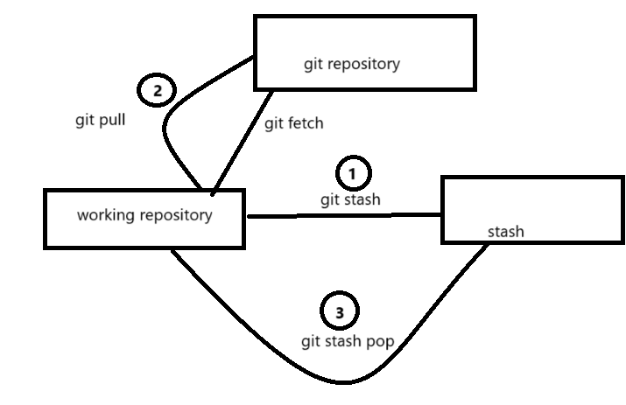

- git clean -f ---forcefully remove the untracked files
- git clean -fd ---- to remove untracked directies
- git clean -xf ---- removes ignored files
- git clean -n ----- to perform a dry run and see which file whould be removed without actually deleting them
- git rev -list –count branch name ----- list commit objects in reverse order
- git config – global help.autocorrect 1 --- this will hep to correct spelling mistakes of git commends
- git cheery-pick<<commit -hash>> --choosing a commit from one branch and applying it to another branch.
- git reflog ----- records updates made to tips of branches and other references in the local repository .

